  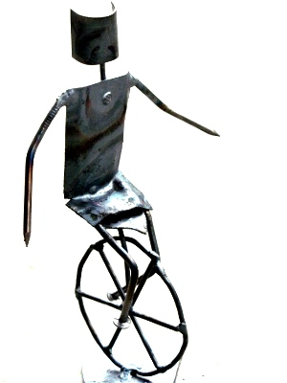 | jovial_cynic’s welded figurines  http://newprotest.org/welding  e-mail: jculley@newprotest.org
  jovial_cynic’s welded figurines
  http://newprotest.org/welding
  e-mail: jculley@newprotest.org
  jovial_cynic’s welded figurines
  http://newprotest.org/welding
  e-mail: jculley@newprotest.org
  jovial_cynic’s welded figurines
  http://newprotest.org/welding
  e-mail: jculley@newprotest.org
  jovial_cynic’s welded figurines
  http://newprotest.org/welding
  e-mail: jculley@newprotest.org
  jovial_cynic’s welded figurines
  http://newprotest.org/welding
  e-mail: jculley@newprotest.org
  jovial_cynic’s welded figurines
  http://newprotest.org/welding
  e-mail: jculley@newprotest.org
  jovial_cynic’s welded figurines
  http://newprotest.org/welding
  e-mail: jculley@newprotest.org
  jovial_cynic’s welded figurines
  http://newprotest.org/welding
  e-mail: jculley@newprotest.org
  jovial_cynic’s welded figurines
  http://newprotest.org/welding
  e-mail: jculley@newprotest.org

